**Level 1: PC Tower Case**

**Outline**

Learn about the internals of a standard PC case by examining physical samples and selecting and labeling images found on-line. Gain deeper knowledge by researching and reporting on specific components.

**Questions**

1. **Find one (or more) images that clearly show the internals of a PC Tower Case.   
   (i.e. Google images using keywords “PC Case Internals”)**
2. **Clearly label the following components (using arrows) on your image of the PC case internals:**
   1. **Motherboard**
   2. **Power Supply**
   3. **Hard Disk Drive**
   4. **Optical Disk Drive (e.g.DVD)**
   5. **USB Expansion Ports**
   6. **Monitor Port**
   7. **Audio Ports**
   8. **Ethernet Port**
   9. **Cooling Fan**

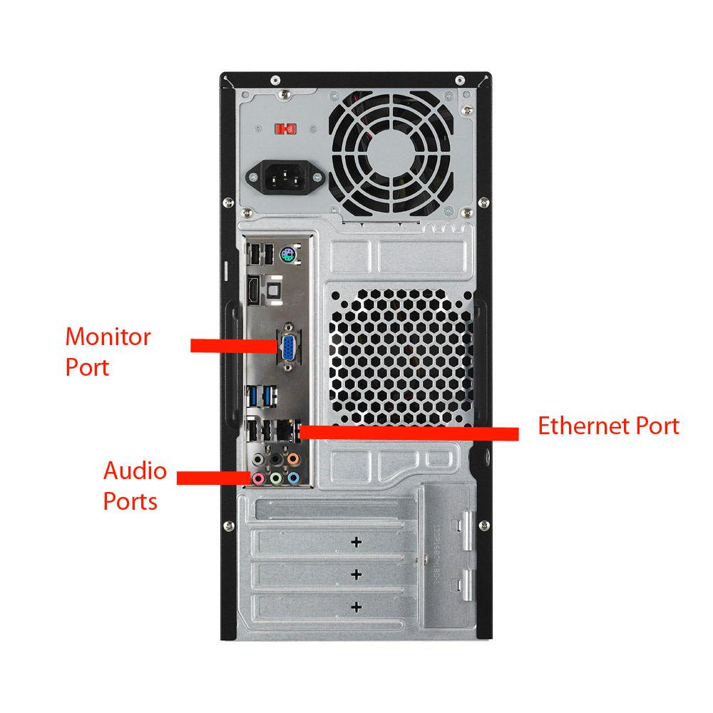

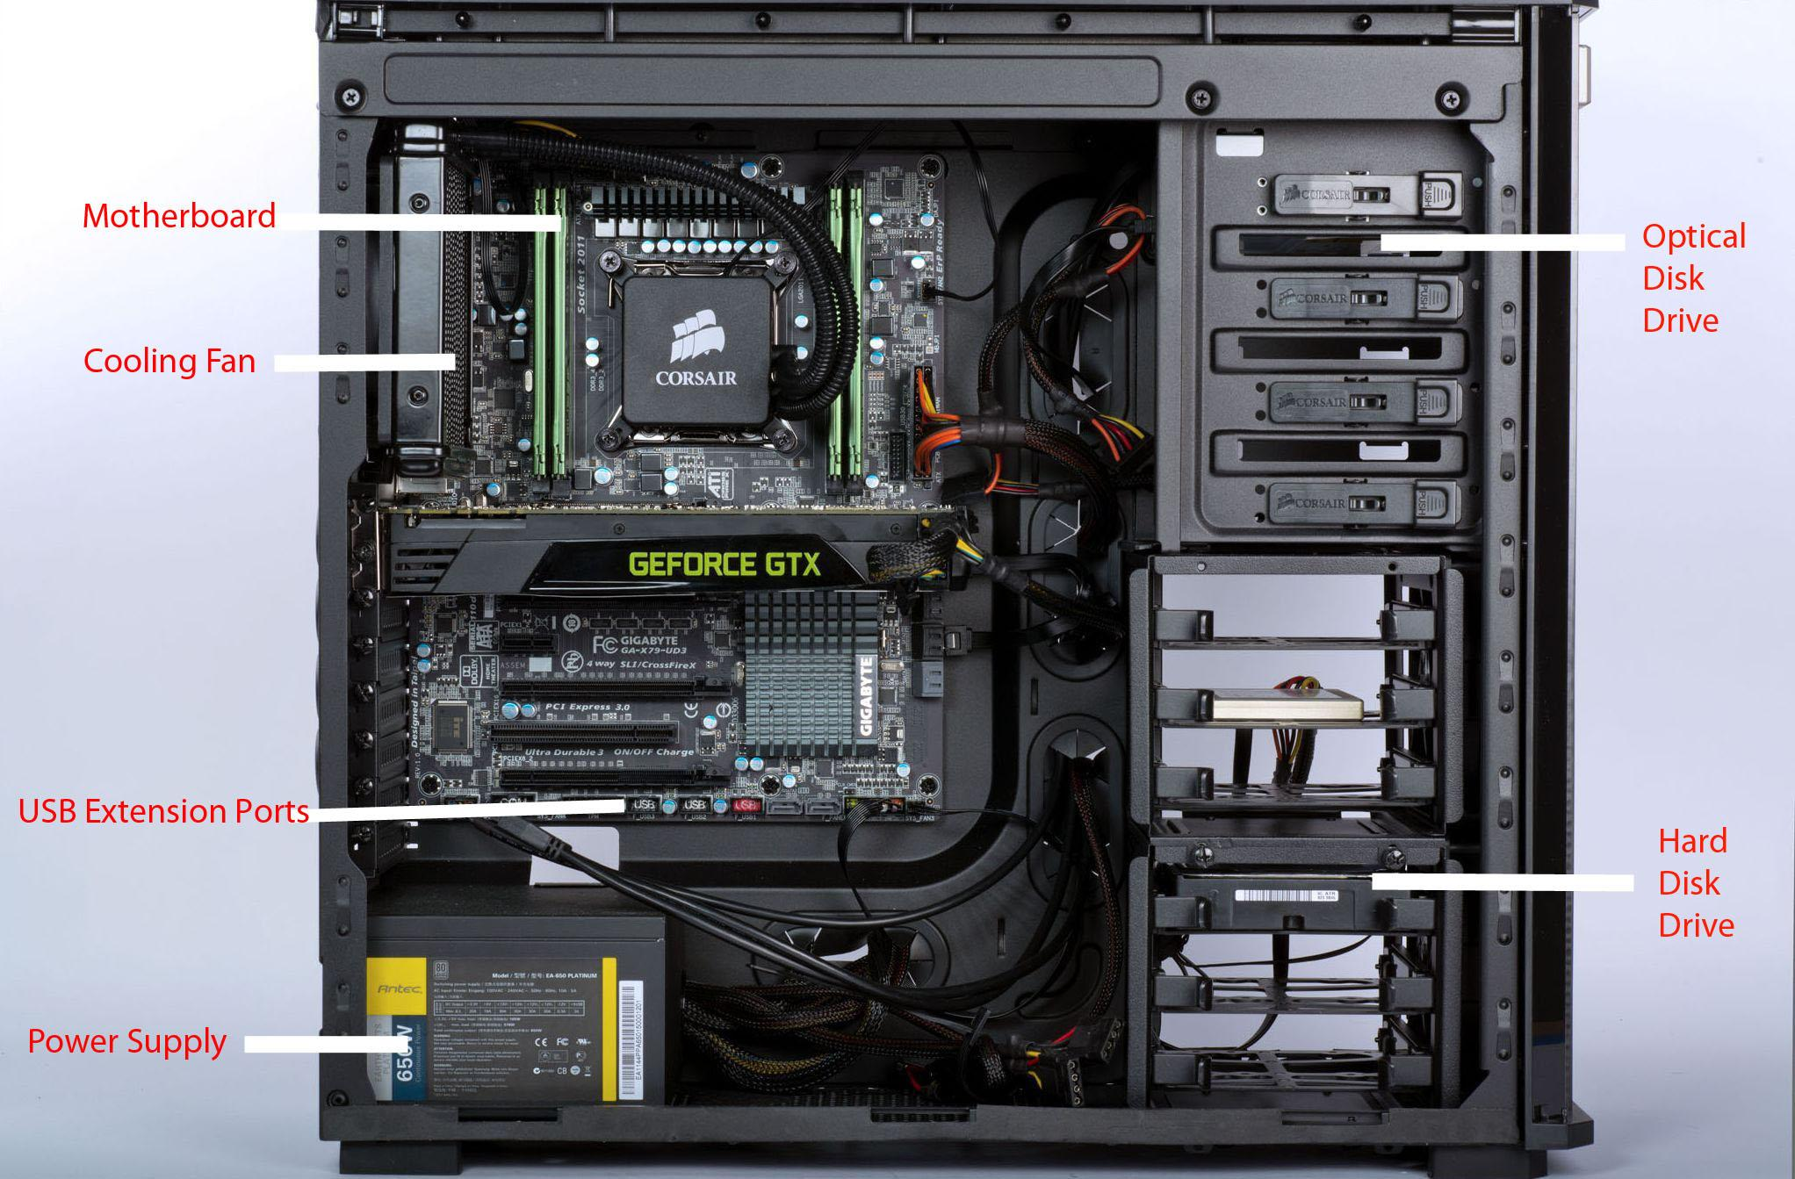

1. **Research more in-depth about “Motherboards”. Make notes on the following:**
   1. **What different versions are currently available (speed and capacity)**

**ATX Motherboards:** The ATX motherboards started in 90’s and are still available. The ATX connector on the motherboard consists of a single connector. These boards are used for Pentium 2,3 and 4 processors.

**LPX Motherboards:** **LPX** (**Low Profile eXtension**) is a motherboard form factor developed by Western Digital in 1987, when it was making motherboards, that was used in the late 1980s and throughout the 1990s. An LPX motherboard is 9" wide x 13" deep, and has different placement of the video, parallel, serial, and PS/2 ports when compared to other motherboards.

**BTX Motherboards:** **BTX** (for **Balanced Technology eXtended**) was designed to alleviate some of the issues that arose from using newer technologies (which often demand more power and create more heat), future development of BTX retail products by Intel was canceled in September 2006 following Intel's decision to refocus on low-power CPUs.

**Pico BTX Motherboards:** Pico BTX is a motherboard form factor that is meant to miniaturize the 12.8 × 10.5 in (325 × 267 mm) BTX standard. Pico BTX motherboards measure 8 × 10.5 in (203 × 267 mm). This is smaller than many current "micro"-sized motherboards, hence the name "pico". These motherboards share a common top half with the other sizes in the BTX line, but support only one or two expansion slots, designed for half-height or riser card applications.

**Mini ITX Motherboards:** **Mini-ITX** is a 17 × 17 cm (6.7 × 6.7 in) motherboard, developed by VIA Technologies in 2001. They are commonly used in small-configured computer systems. Originally, they were a niche product, designed for fan-less cooling with a low power consumption architecture.

* 1. **How the component has changed since the 1980’s**

The first ever type of motherboard was the AT motherboard which was produced in the mid 80s lasted a good span from the Pentium p5 to the times when Pentium 2 had been started to be used. Advanced technology extended, or popularly known as the ATX, are the motherboards which were produced by the Intel in mid 90’s as an improvement from the previously working motherboards such as AT. This type of motherboards differ from their AT counterparts in the way that these motherboards allow the interchangeability of the connected parts. The low profile extension motherboards, better known as LPX motherboards, were created after the AT boards in the 90’s. The major difference between these and previous boards is that the input and output ports in these boards are present at the back of the system. This concept proved to be beneficial and was also adopted by the AT boards in their newer versions. BTX was developed to reduce or avoid some of the issues that came up while using latest technologies. Newer technologies often demand more power and they also release more heat when implemented on motherboards in accordance with the circa-1996 ATX specification. These are the main motherboards that show and display how it has evolved from the very first AT motherboard.

1. **Research more in-depth about “Hard Disk Drives”. Make notes on the following:**
   1. **What different versions are currently available (speed and capacity)**

**Parallel Advanced Technology Attachment (PATA):** Parallel ATA (Parallel Advanced Technology Attachment or PATA) is a standard for connecting hard drives into computer systems. As its name implies, PATA is based on something called parallel signaling technology and dates back to the 1980s. The connections for PATA devices were originally made using 40-conductor ribbon cables. These were later supplanted by 80-conductor cable. The maximum workable cable length is 46 centimeters (about 18 inches). This means that PATA cables are only practical for use with internal drives.

**Serial ATA (SATA):** Serial ATA (Serial Advanced Technology Attachment or SATA) is a standard for connecting and transferring data from hard disk drives (HDDs) to computer systems. As its name implies, SATA is based on something called serial signaling technology. SATA has several advantages over the Parallel ATA (PATA) hard drives developed in the 1980s. SATA cables are thinner, more flexible and less massive than the ribbon cables required for conventional PATA hard drives.

**Small Computer System Interface (SCSI):** They make use of the Small Computer System Interface to connect to the computer. SCSI drives can be connected internally or externally. Devices that are connected in a SCSI have to be terminated at the end.

**Solid State Drives (SSD):** These are the latest in drive technology that we have in the computer industry. They are totally different from the other drives in that they do not consist of moving parts. They also do not store data using magnetism. Instead, they make use of flash memory technology. They make use of integrated circuits or semiconductor devices to store data permanently, at least until they are erased.

* 1. **How the component has changed since the 1980’s**

When the IBM produced the first hard drive on 13 September 1956, few people had imagined the impact that it would have on our daily lives for over 50 years. The RAMAC ("Random Access Method of Accounting and Control") was the size of two refrigerators and weighed a ton. The RAMAC was available for long-term loan at a modest sum of USD $35,000, equivalent to USD $254,275 today. Twenty-five years later, the first hard drive for PC was invented. This had led to a series of innovations and inventions that is now our modern day hard drives.

**NOTE:**

* Download the on-line version of this module (from the class GitHub repository)
* Questions for Level 2 and Level 3 are in the on-line version of this module
* Provide your answers in a MS Word, PowerPoint, or equivalent format
* Upload your answers to your personal GitHub repository

**Level 2: PC Motherboard**

**Outline**

Learn about the structure of a standard PC motherboard by examining physical samples and selecting and labeling images found on-line. Gain deeper knowledge by researching and reporting on specific components.

**Questions**

1. **Find one (or more) images that clearly show the layout of a PC Motherboard.   
   (i.e. Google images using keywords “PC Motherboard”)**
2. **Clearly label the following components (using arrows) on your image of the PC motherboard:**
   1. **CPU (and fan)**
   2. **RAM Memory**
   3. **Disk Drive Interface (IDE or SATA)**
   4. **GPU Graphics Processor (either on-board or Graphics Card)**
   5. **Sound Processor (either on-board or Sound Card)**
   6. **Wi-Fi / Ethernet Network Interface (either on-board or Graphics Card)**

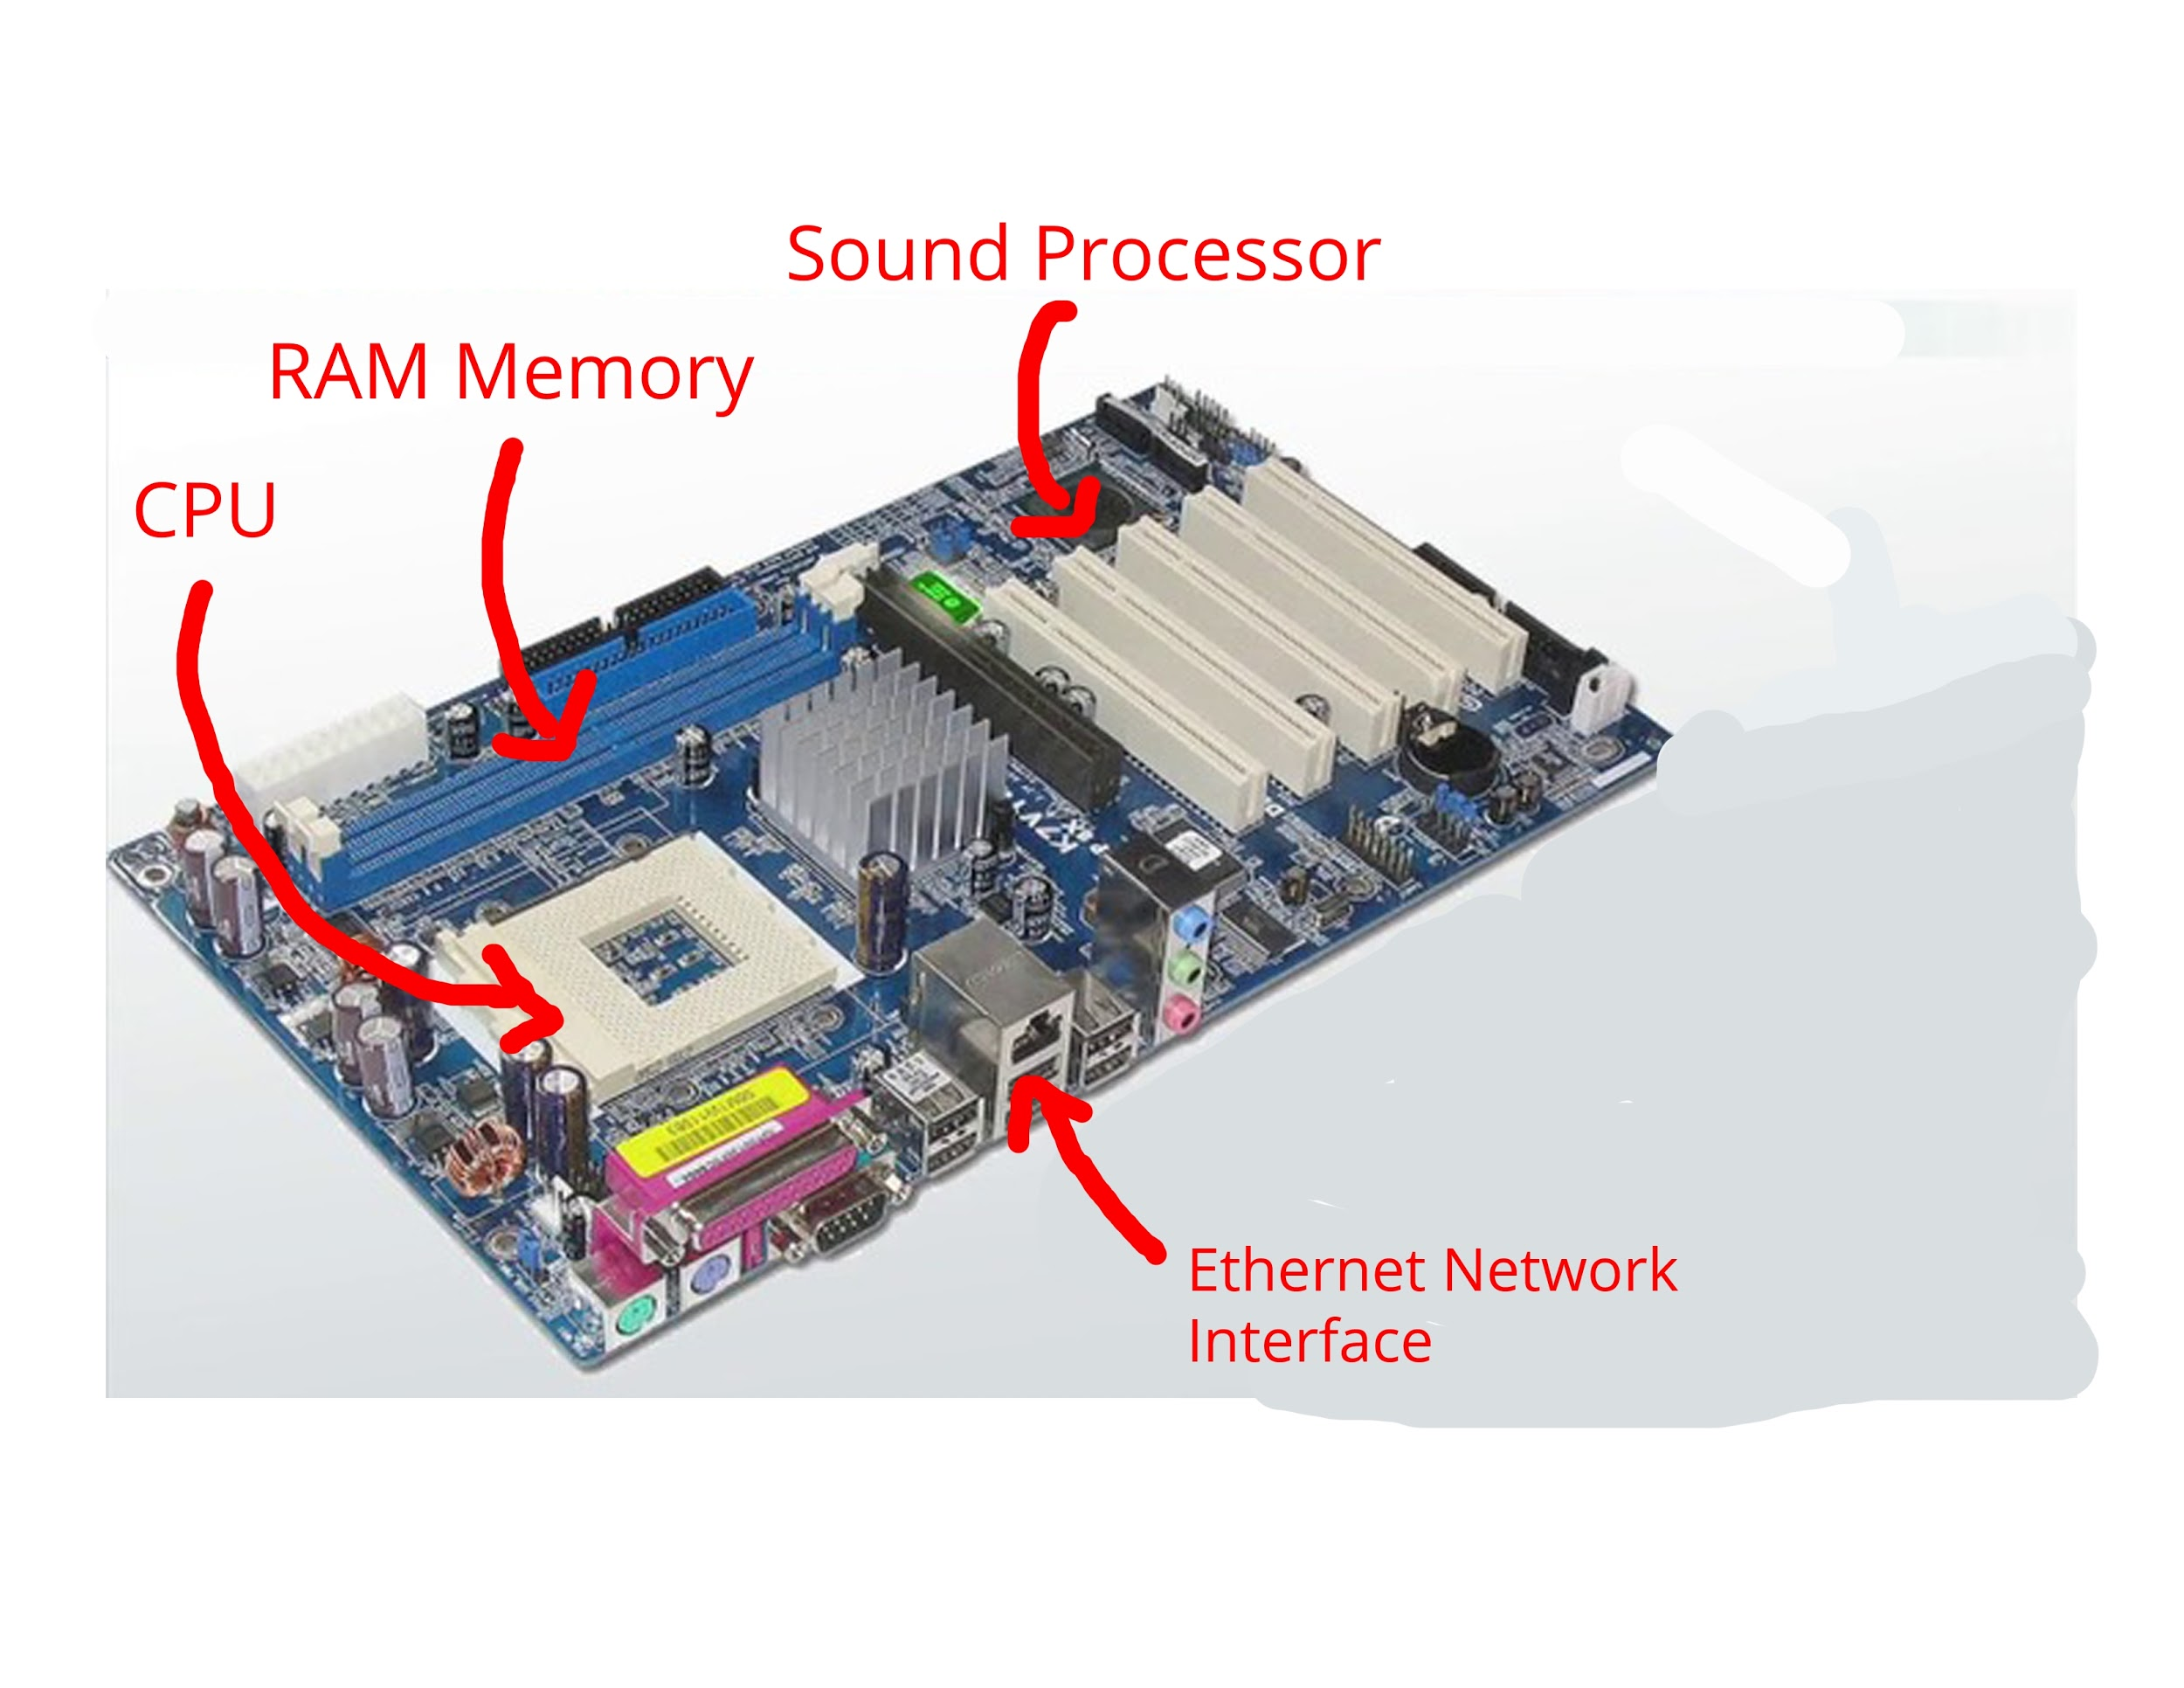

1. **Research more in-depth about “CPU Processor Chip”. Make notes on the following:**
   1. **What different versions are currently available (speed and capacity)**

The 2 most popular CPU brands today are AMD and Intel. Intel’s main CPU chipset includes the intel i3, i5, i7, and i9. AMD’s 4 chipsets are the Socket TR4, Socket AM4, 9 Series, and A series. Intel i3’s have 2 cores and i5 & i7 have 4 cores.

i3-7100=3M Cache, 3.90 GHz

i5=835OU= 6M Cache, up to 3.60 GHz

i7=8565=8M Cache, up to 4.60 GHz

* 1. **How the component has changed since the 1980’s**

Intel's first CPU, or Central Processing Unit, was a 4-bit processor, with a clock speed of 740 kHz, and was developed in November, 1971, by the computer giant, Intel. The Intel 4004's successor, and the first 8-bit Central Processing Unit, the 8008 was available in clock speeds of 500 kHz and 800 kHz. It became the standard CPU for computers. Again, developed by Intel, the first 16-bit microprocessor was codenamed P1, but was actually called the Intel 8086, and could run at clock speeds of 5 MHz to 10MHz.As a newer version of the Intel 80286, the 80386 was a 32-bit chip, and ran at a speed of 12MHz. The Intel Pentium, was a 64-bit microprocessor, and was released by Intel at a hefty price of $878.00, and with clock speeds between 60MHz, and 300MHz. Eventually these innovations led to the modern day CPUs we have today.

1. **Research more in-depth about “RAM Memory”. Make notes on the following:**
   1. **What different versions are currently available (speed and capacity)**

* Static RAM (SRAM)
* Dynamic RAM (DRAM)
* Synchronous Dynamic RAM (SDRAM)
* Single Data Rate Synchronous Dynamic RAM (SDR SDRAM)
* Double Data Rate Synchronous Dynamic RAM (DDR SDRAM, DDR2, DDR3, DDR4)
* Graphics Double Data Rate Synchronous Dynamic RAM (GDDR SDRAM, GDDR2, GDDR3, GDDR4, GDDR5)
* Flash Memory
  1. **How the component has changed since the 1980’s**

The first form of RAM came about in 1947 with the use of the Williams tube. It utilized a (CRT (cathode ray tube) and data was stored on the face of the CRT as electrically charged spots. The second widely used form of RAM was magnetic-core memory, invented in 1947. Frederick Viehe is credited with much of the work, having filed for several patents relating to the design. Magnetic-core memory works through the use of tiny metal rings and wires connecting to each ring. One bit of data could be stored per ring and accessed at any time. However, RAM as we know it today, as solid-state memory, was first invented in 1968 by Robert Dennard. Known specifically as dynamic random access memory, or DRAM, transistors were used to store bits of data.

**Level 3: Peripheral Devices**

**Outline**

Learn about how peripheral devices are connected to the back side of a typical PC tower case. Examine physical samples, select and labeling images found on-line and gain deeper knowledge by researching and reporting on specific components.

**Questions**

1. **Find one (or more) images that clearly show the layout of the back of a typical PC tower case.   
   (i.e. Google images using keywords “Back Of PC Tower”)**
2. **Clearly label the following components (using arrows) on your image of the back of a typical PC tower case:**
   1. **Power cord and power switch**
   2. **Monitor Interface (VGA or DVI or HDMI)**
   3. **Mouse Interface (USB or PS/2)**
   4. **Keyboard Interface (USB or PS/2)**
   5. **USB Ports**
   6. **Audio Inputs / Outputs**
   7. **Ethernet Interface**

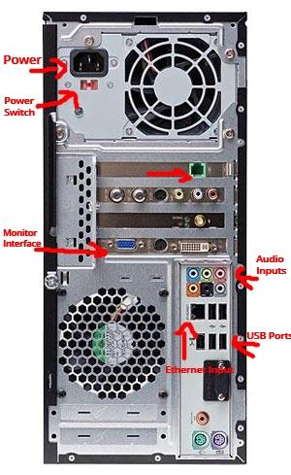

1. **Research more in-depth about “Monitor Technology”. Make notes on the following:**
   1. **What different versions are currently available (e.g. VGA / DVI, Flat Panel Technology))**

**VGA:** Short for Video Graphics Adapter or Video Graphics Array, VGA is a popular display standard developed by IBM and introduced in 1987. VGA provides 640 x 480 resolution color display screens with a refresh rate of 60 Hz and 16 colors displayed at a time. If the resolution is lowered to 320 x 200, 256 colors are shown.

**DVI:** Short for Digital Visual Interface, DVI is a video display interface. It was developed to be an industry standard for transmitting digital video content to display devices at resolutions as high as 2560 x 1600. Common devices that utilize the DVI connection are computer monitors and projectors. DVI can even be used with some TVs, although HDMI is more common as only some DVI cables can transmit audio signals. The DVI connector (shown below) may have one of three names depending on the signals it supports: DVI-A (analog only), DVI-D (digital only), or DVI-I (both digital and analog).

**Flat Panel Technology:** Sometimes abbreviated as FPD, a flat-panel display is a display technology which succeeds CRT as the new standard for desktop computer displays. Unlike CRT monitors, flat-panel displays use LCD (liquid crystal display) or LED (light-emitting diode) screens, making them lighter and thinner.

* 1. **How the component has changed since the 1980’s (e.g. Display Resolution, Technology)**

The first commercial colour CRT was produced in 1954. CRTs were the single most popular display technology used in television sets and computer monitors for over half a century; it was not until the 2000s that LCDs began to gradually replace them.

1. Research more in-depth about “External Portable Storage”. Make notes on the following:
   1. **Floppy Disks** : A floppy disk, also known as a floppy, diskette, or simply disk, is a type of disk storage composed of a disk of thin and flexible magnetic storage medium, sealed in a rectangular plastic enclosure lined with fabric that removes dust particles. Floppy disks are read and written by a floppy disk drive.
   2. **CD-ROM / DVD / Recordable CD/DVD**: A CD-ROM is a pre-pressed optical compact disc that contains data. Computers can read—but not write to or erase—CD-ROMs, i.e. it is a type of read-only memory. During the 1990s, CD-ROMs were popularly used to distribute software and data for computers and fourth generation video game consoles. Compact disc is a digital optical disc data storage format that was co-developed by Philips and Sony and released in 1982. The format was originally developed to store and play only sound recordings but was later adapted for storage of data. DVD is a digital optical disc storage format invented and developed in 1995. The medium can store any kind of digital data and is widely used for software and other computer files as well as video programs watched using DVD players.
   3. **USB Memory Drives**: USB is an industry standard that establishes specifications for cables, connectors and protocols for connection, communication and power supply between personal computers and their peripheral devices.
   4. **Compact Flash Memory:** A CompactFlash card (CF card) is a memory card format developed by SanDisk in 1994 that uses flash memory technology to store data on a very small portable device
   5. **Cloud Based Storage:** Cloud storage is a cloud computing model in which data is stored on remote servers accessed from the internet, or "cloud." It is maintained, operated and managed by a cloud storage service provider on a storage servers that are built on virtualization techniques.

**Level 4: PC Component Presentation**

**Outline**

Explore the development and features of a specific PC hardware component through deeper research and investigation. Work in partners to create a short presentation. Deliver the presentation to the class.

Each group will research a unique PC hardware component . Your specific topic will be assigned from the list provided below.

**Presentation Structure**

1. Explain what the PC component does and how it fits together with other components to make up a fully functioning PC.
2. Explain how the PC component works. Provide a diagram (image) showing the main parts of the component.
3. Research the current state of the art of the component in terms speed, capacity (size), and other related factors.
4. Research on-line suppliers that sell the PC Component. List the specifications for the available products and the cost (price).
5. Research how the PC component has changed and evolved since the early days of PCs in the 1980’s. Cover each of the following topics separately:
   1. Component Speed
   2. Component Size / Capacity
   3. Two other specifications specific to the PC component (ask Mr. Nestor)

**PC Component Topics**

|  |  |  |
| --- | --- | --- |
| **Topic** | **Partner 1** | **Partner 2** |
| CPU Microprocessor Chip |  |  |
| Motherboard Layout |  |  |
| Computer Graphics |  |  |
| Sound & Audio |  |  |
| Hard Disk Drives |  |  |
| Removable Disk Storage |  |  |
| Network / Internet Connectivity |  |  |
| Mouse / Pointing Devices |  |  |
| Monitor & Display Technology |  |  |
| Printers & Output Technology |  |  |